# **AMAZON INTERVIEW**

**[How To PASS an Amazon Job Interview!](https://www.youtube.com/watch?v=1kdSo8HTC3k)**

[**AMAZON MANAGER Interview Questions And Answers!**](https://www.youtube.com/watch?v=PjjMV1lu9M4)

[**AMAZON LEADERSHIP PRINCIPLES Interview Questions & Answers!**](https://www.youtube.com/watch?v=Ta9tCwcMbXs)

[**AMAZON'S 14 Leadership Principles INTERVIEW QUESTIONS & ANSWERS!**](https://www.youtube.com/watch?v=lwXGXWrGFUA) 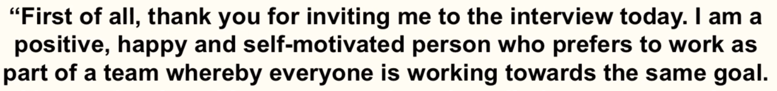

# [**Tell me about yourself and why you think you’ll make a great manager for Amazon**](https://youtu.be/PjjMV1lu9M4?t=147)

Good morning. First of all, thank you for inviting me to the interview today. My name is Hoang Nguyen. I have been working in the Software Development field for more than 23 years to lead and manage Software Engineering teams to deliver secure, high quality, large scale projects using Agile Methodology.

I am currently working for Cotiviti, a Healthcare Services, and responsible for managing the Software engineering teams onshore and offshore using Agile Methodology. I am a combination of a technical engineering architect and people management.

If I had to describe myself in a few words, it would be that I am hard-working, professional, dedicated and committed to achieving the strategic aims and objectives of my employer through strong management skills. I have been working towards this position in management for a number of years now, and I have been waiting for a manager position to come up with your company in particular.

I pride myself on setting high standards and feel you would be extremely pleased with my ability to not only motivate and lead my team, but also inspire them to be the best they can be and consistently improve the company we are working for.

I understand that Amazon has only reached the status it has as the largest online retailer in the world by employing staffs and managers who all work towards achieving the same goal. I can assure you I have the necessary qualities and attributes to perform the role to a very high standard.

Outside of work, I like to keep myself fit and active which means when I am at work, I can concentrate fully on my tasks and do things professionally. I have been watching the growth of Amazon from afar over the years, and I would love to be a part of your success story moving forward.

If you employ me as your manager, I will work extremely hard to ensure both myself and the team I am managing all work hard to ensure Amazon stays at the forefront of the industry.

# [**Tell me about yourself and why you think you’ll make a great manager for Amazon**](https://youtu.be/PjjMV1lu9M4?t=147)

First of all, thank you for inviting me to the interview today. My name is Hoang Nguyen. I have been working in the Software Development field for more than 25 years. I am currently working for Cotiviti, a Healthcare Services, and responsible for managing the Software engineering teams onshore and offshore using Agile Methodology.

If I had to describe myself in a few words, it would be that I am hard-working, professional, dedicated and committed to achieving the strategic aims and objectives of my employer through strong management skills. I have been working towards this position in management for a number of years now, and I have been waiting for a manager position to come up with your company in particular.

I pride myself on setting high standards and feel you would be extremely pleased with my ability to not only motivate and lead my team, but also inspire them to be the best they can be and consistently improve the company we are working for.

I have been watching the growth of Amazon from afar over the years, and I would love to be a part of your success story moving forward.

# **ABOUT ME**

* I take pride in enabling the best work of others on the team. I think ahead to anticipate the needs of my teammates and I give and get all the facts making it easy for others to make decisions.
* I work hard and want to have fun while I do so. I celebrate wins and remember to enjoy the journey as we build something iconic.
* I can work both fast and right and don't view them as trade-offs. I understand when things require precision and accuracy and where 80% gets me to the desired outcome.
* I thrive on being pushed and challenged. I communicate effectively both in written form and live / on my feet – I am not fazed by tough questions in the moment.
* I strike the right balance of putting enough work in to share something, but not going off into a corner for weeks at a time to polish something to perfection.
* I operate like an owner & expect other to as well. I take personal responsibility and value personal responsibility in others.

**EXPERIENCE**

* I have 6+ years of experience in software development & delivery.
* I have 2+ years of managing full stack engineering teams, delivering high quality software for customers
* I am technical enough to ask engineers good questions about architecture and product decisions.
* I have experience with modern software engineering concepts such as Domain Driven Design, distributed systems, event sourcing and messaging based infrastructure.
* I have expertise in one of programming languages such as C#, JavaScript, Typescript, Java or Python.
* I have experience establishing successful partnerships with key stakeholders such as Product Managers, Designers & other domain experts

# **2.** [**Why do you want to work for Amazon as a manager?**](https://youtu.be/PjjMV1lu9M4?t=212)

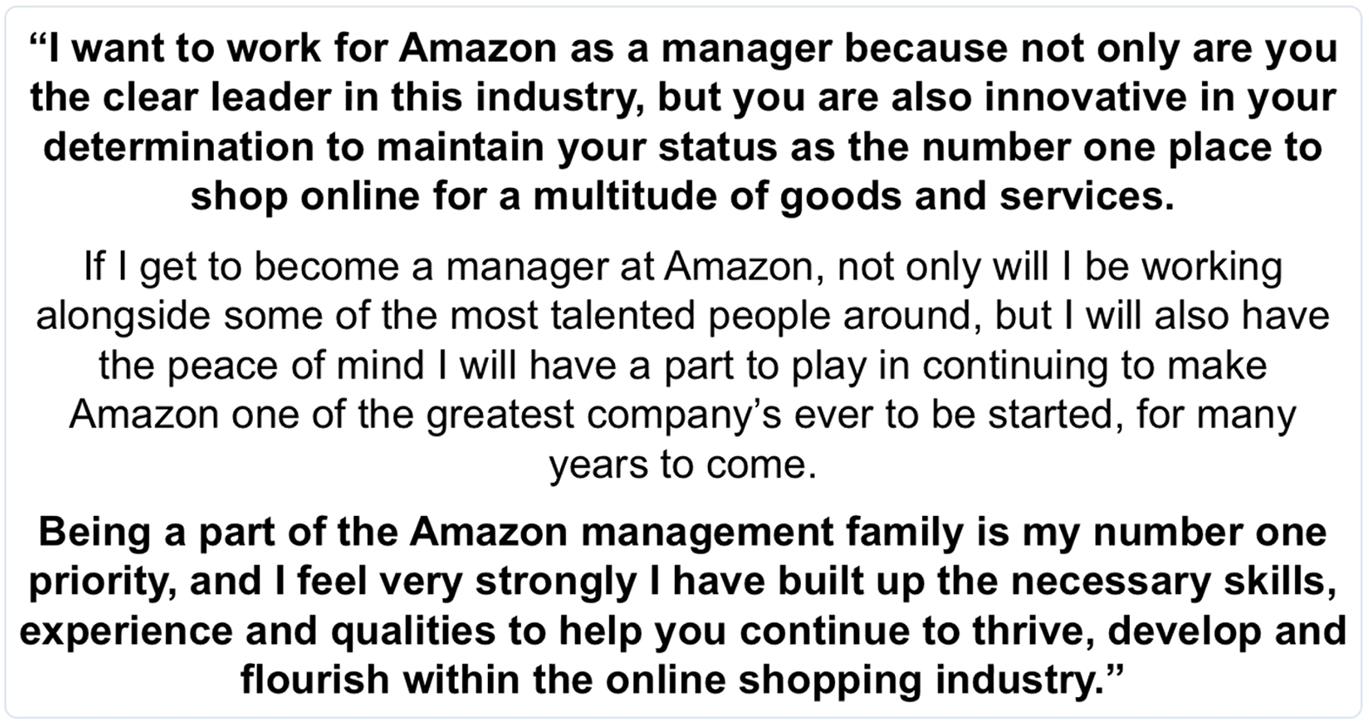

# **2b.** [**Why do you want to work for Amazon?**](https://youtu.be/1kdSo8HTC3k?t=339)

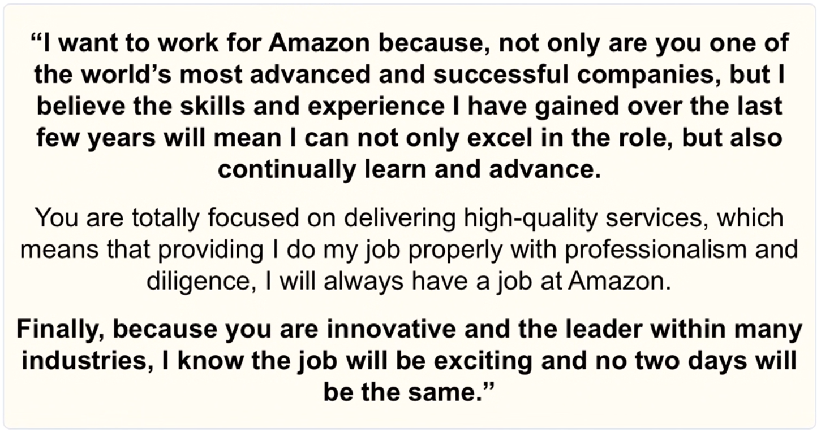

# **3.** [**Tell me the different skills and attributes you possess that will help you to become a competent manager for Amazon**](https://youtu.be/PjjMV1lu9M4?t=271)**?**

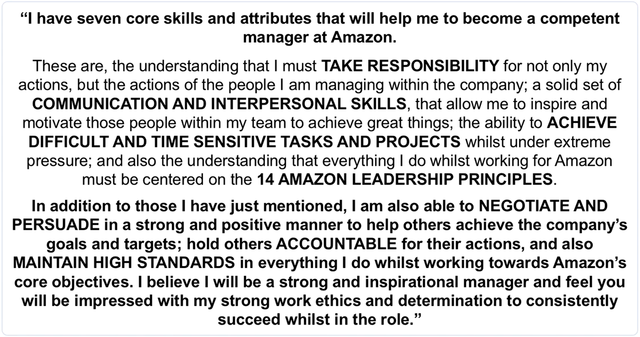

# **4.** [**Describe a time when you demonstrated one of the Amazon Leadership Principles in a previous role**](https://youtu.be/PjjMV1lu9M4?t=373)**? (Insist on The highest Standards)**

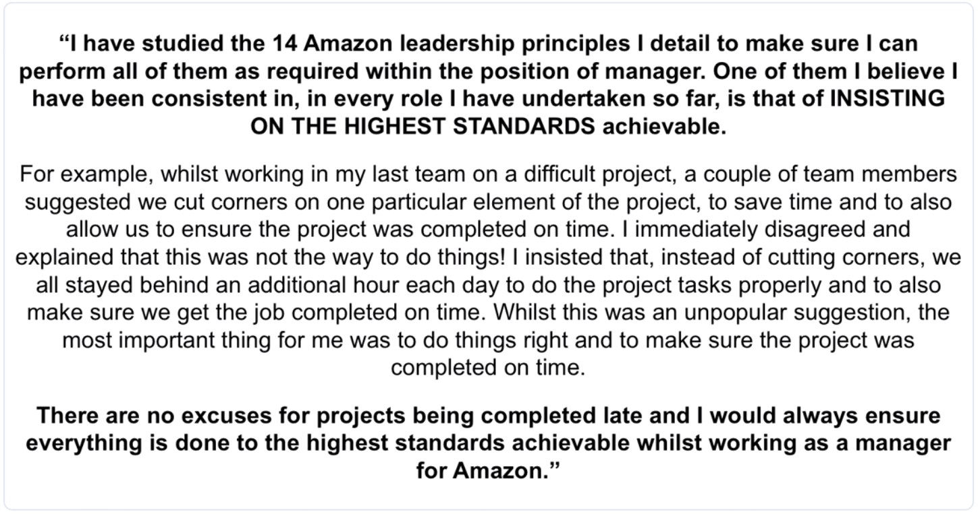

# **5.** [**How would you handle a difficult and unproductive member of your team as their manager?**](https://youtu.be/PjjMV1lu9M4?t=449)

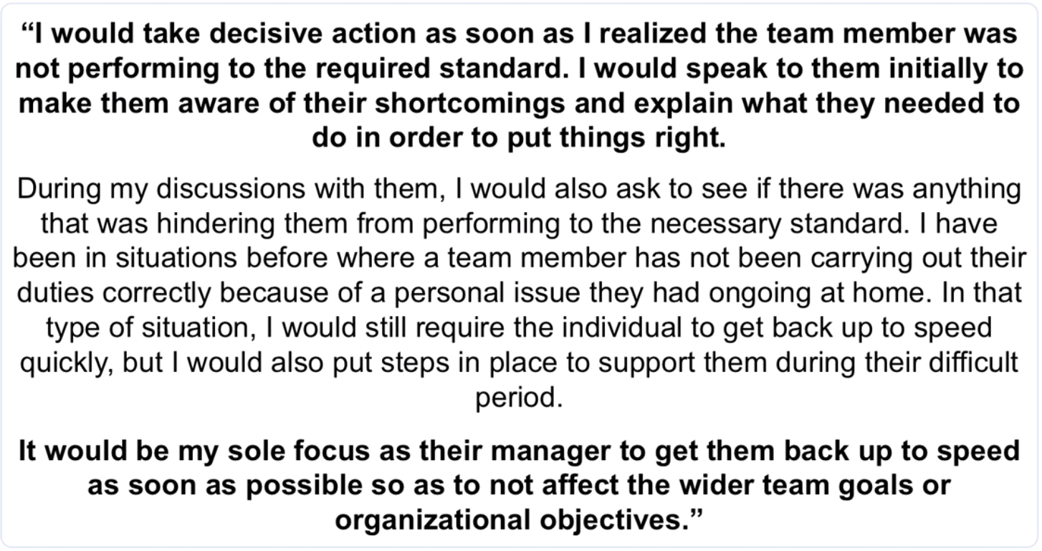

# **6.** [**Tell me about a time when you had to make a quick decision that was going to have a significant impact on the organization**](https://youtu.be/lwXGXWrGFUA?t=444)**?**

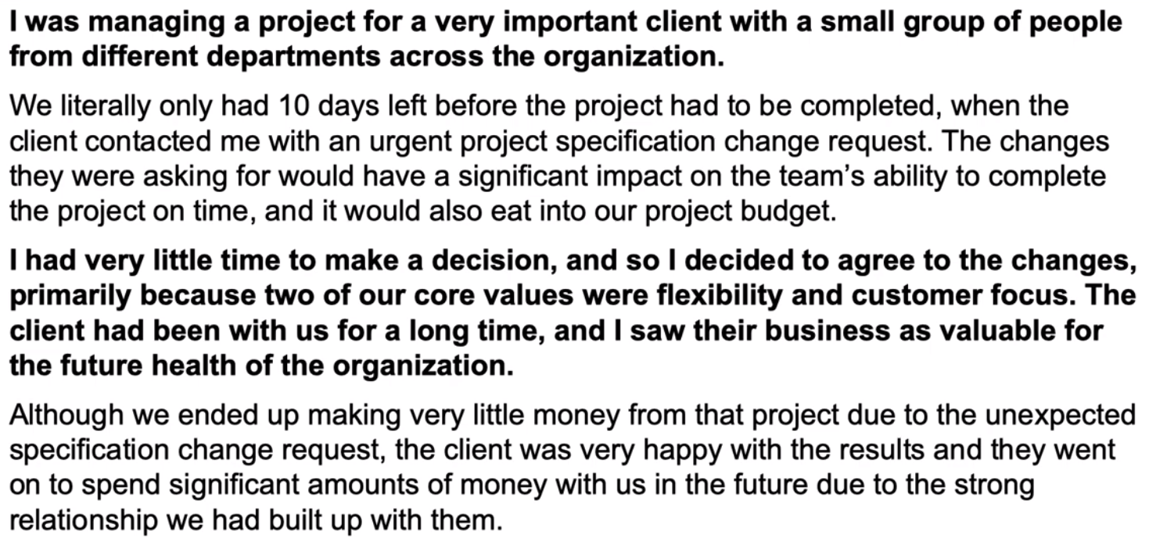

# **7.** [**Describe a situation when you had to work with incomplete data or information**](https://youtu.be/lwXGXWrGFUA?t=535)**?**

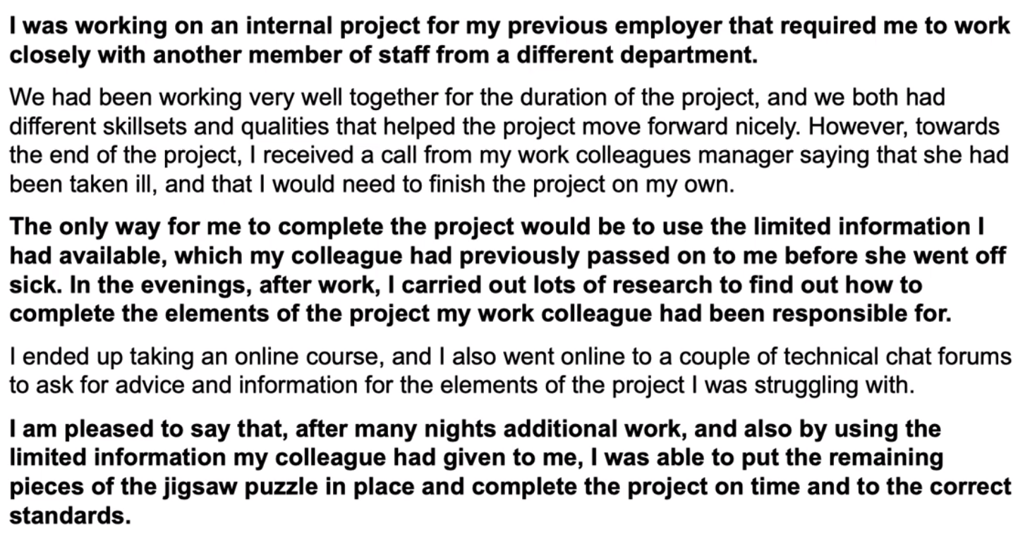

# **8.** [**Tell me about a time when you had to take a calculated risk at work**](https://youtu.be/lwXGXWrGFUA?t=661)**?**

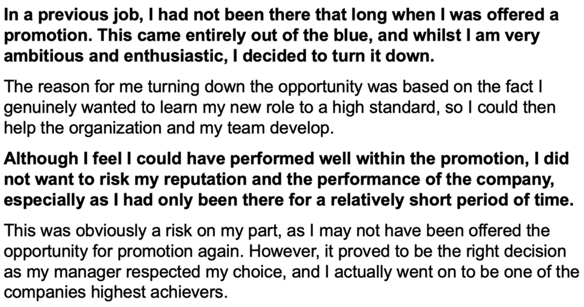

# **9.** [**Tell me about a time when you found a simple solution to a complex problem**](https://youtu.be/lwXGXWrGFUA?t=725)**?**

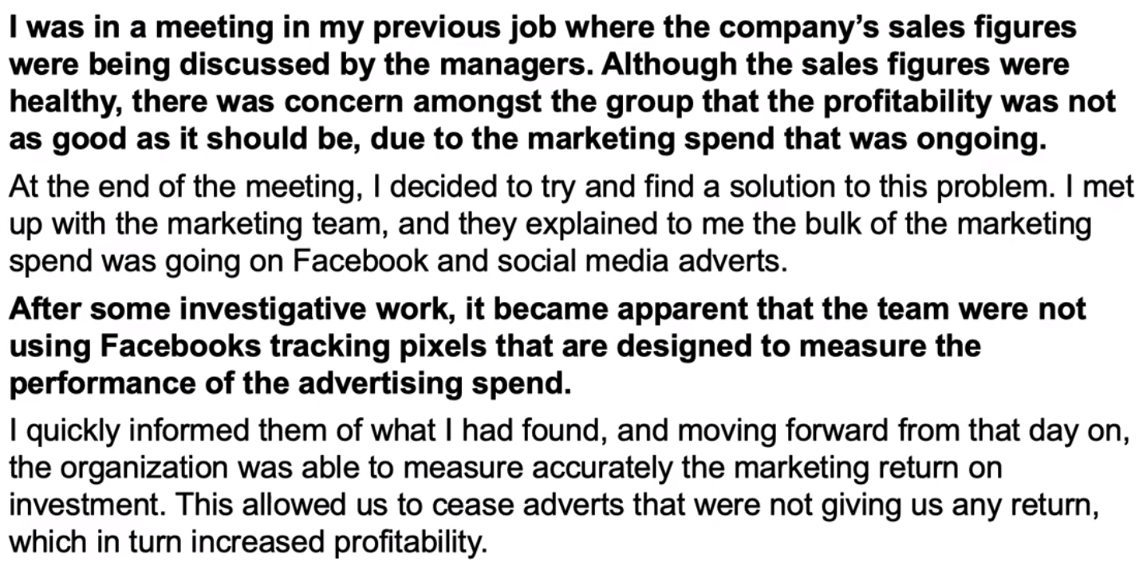

# **10.** [**Describe your style of management**](https://youtu.be/EWGlwdJ5sWQ?t=257)**?**

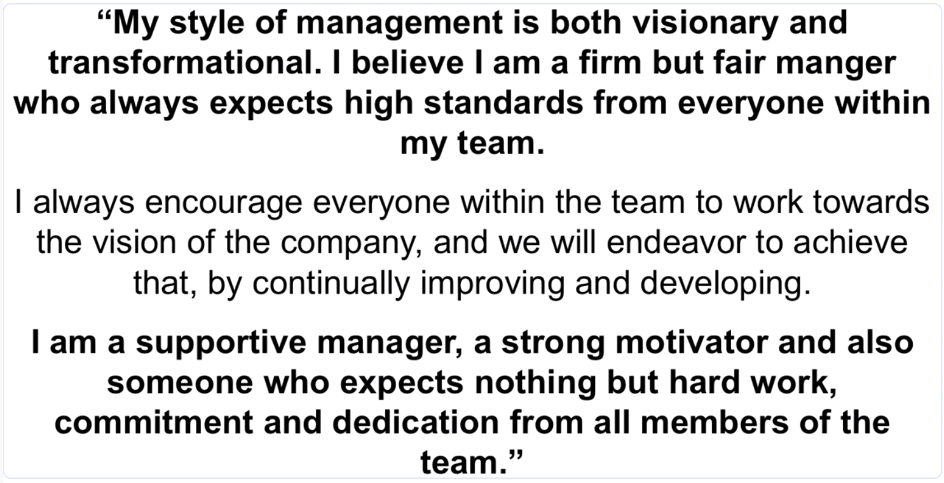

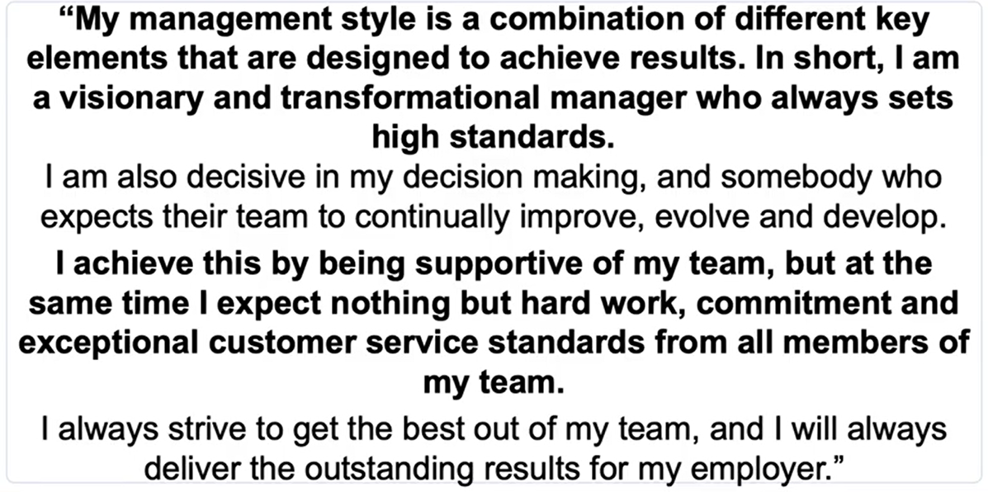

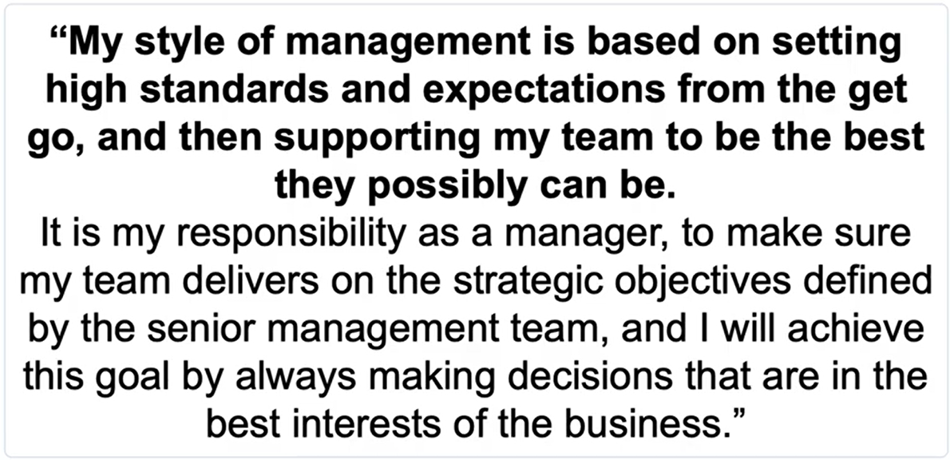

# **11.** [**At Amazon, we pride ourselves on constantly achieving great things. Tell me about one of your greatest achievements**](https://youtu.be/1kdSo8HTC3k?t=533)**?**

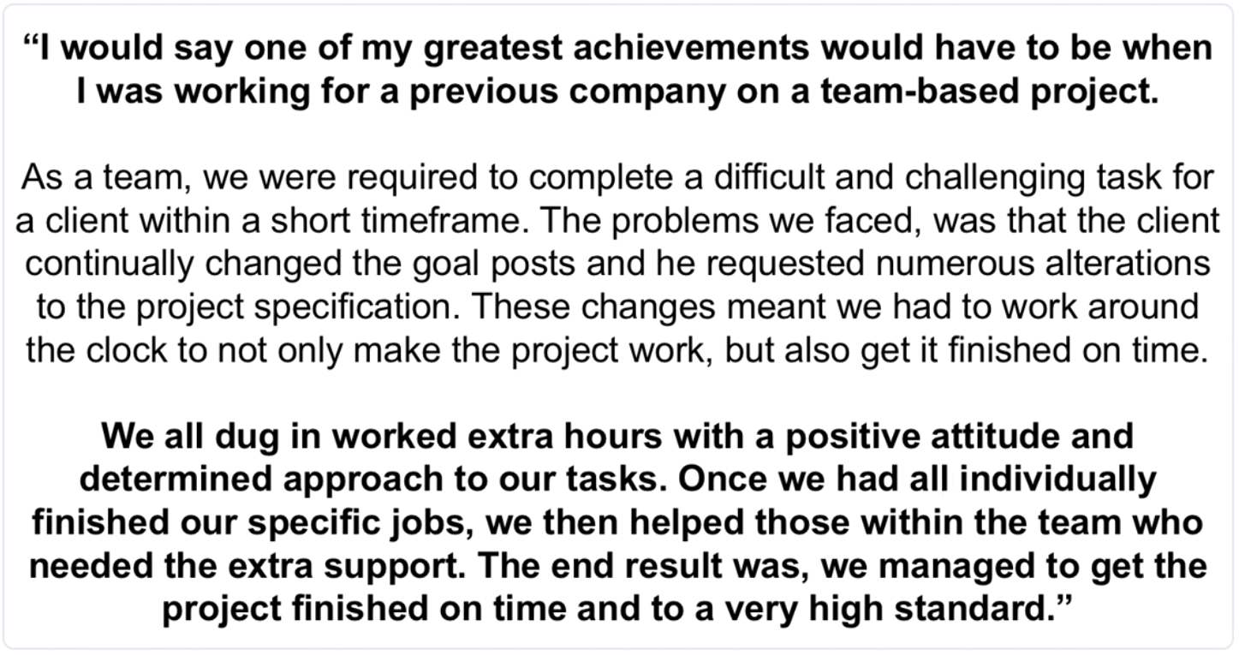

# **Q. Tell me about a time when you failed at work (Ownership)?**

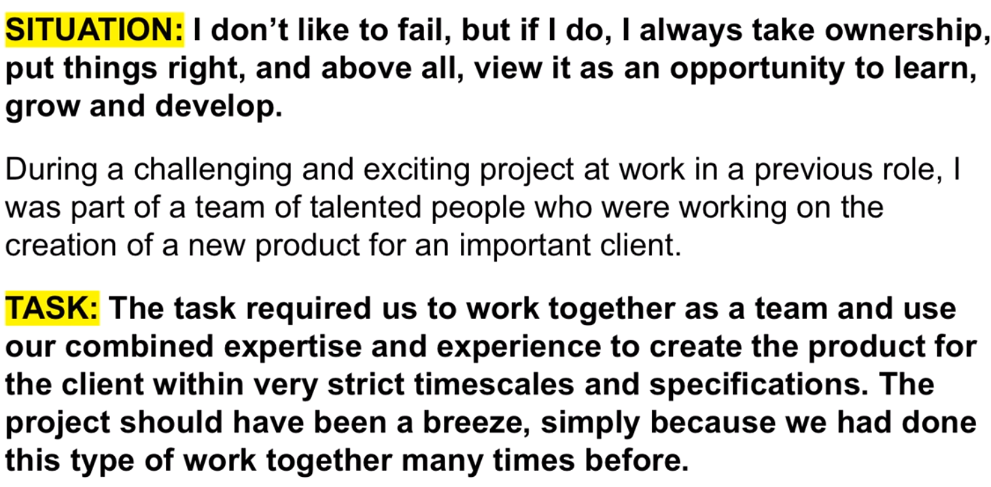 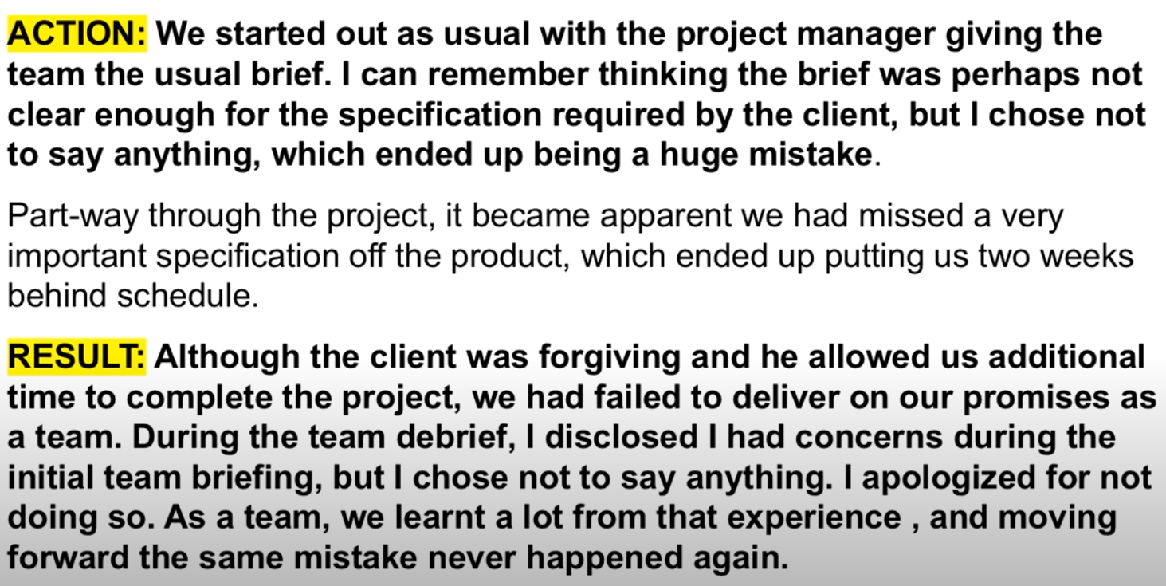

# **Q. Describe a time when you overcame a difficult challenge at work? (Deliver Result)**

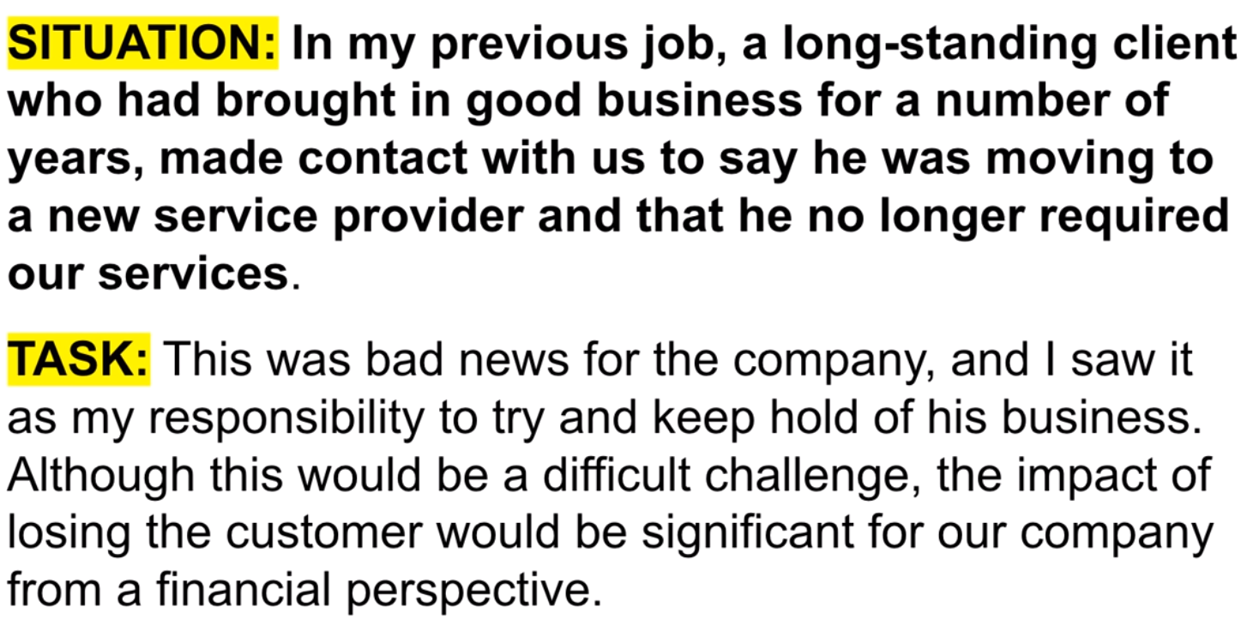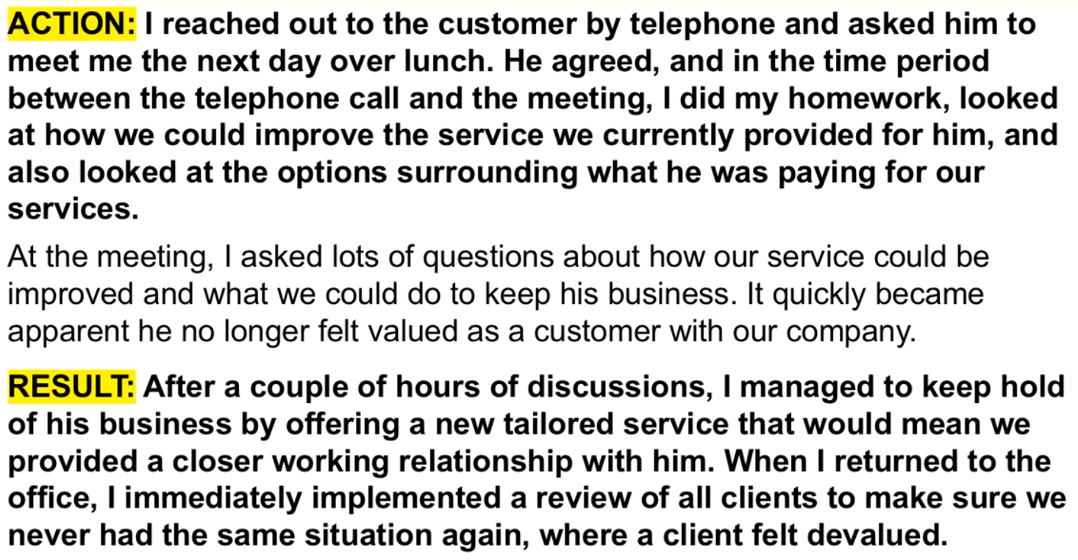

# **Q. Tell me a time when you have a disagreement with somebody at work? (Have Backbone, disagree & commit)**

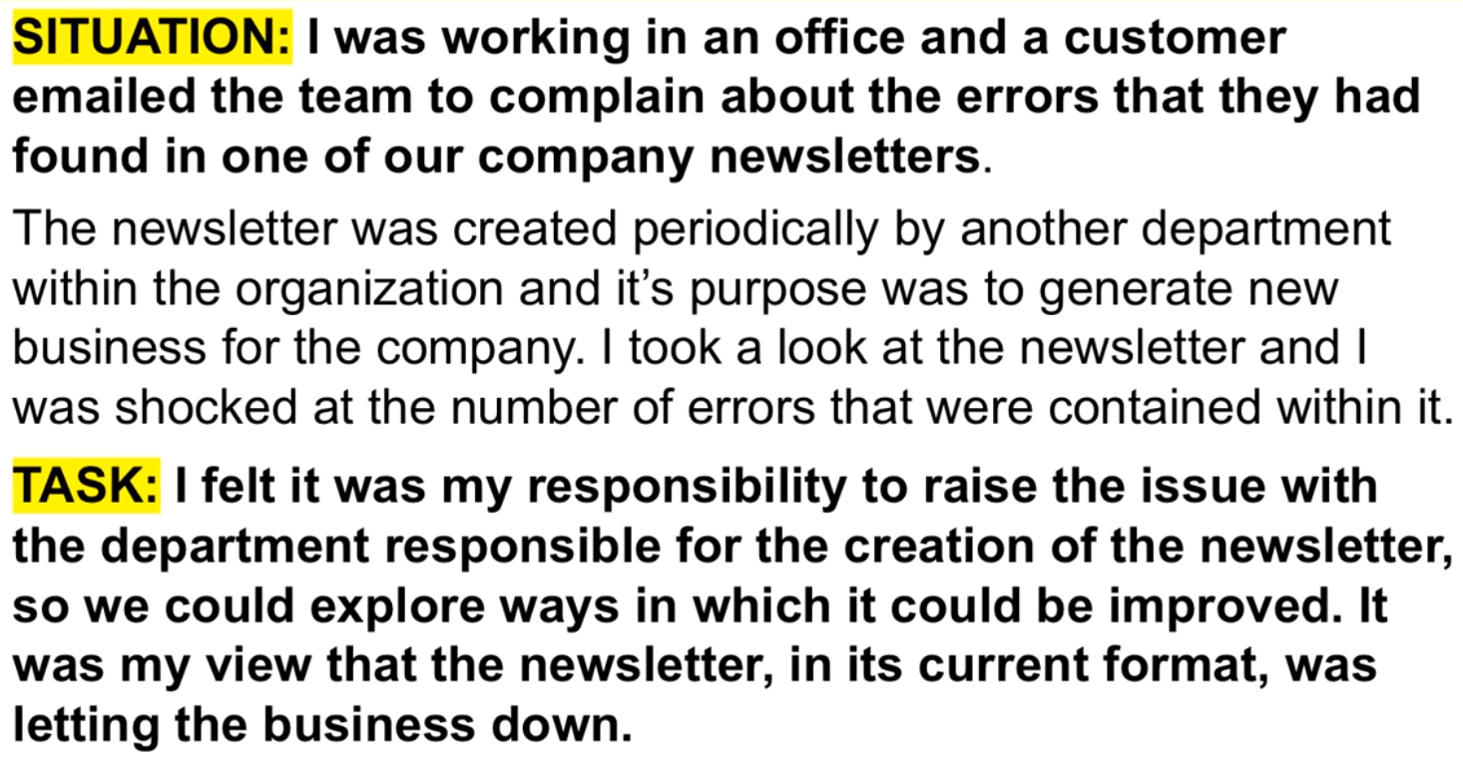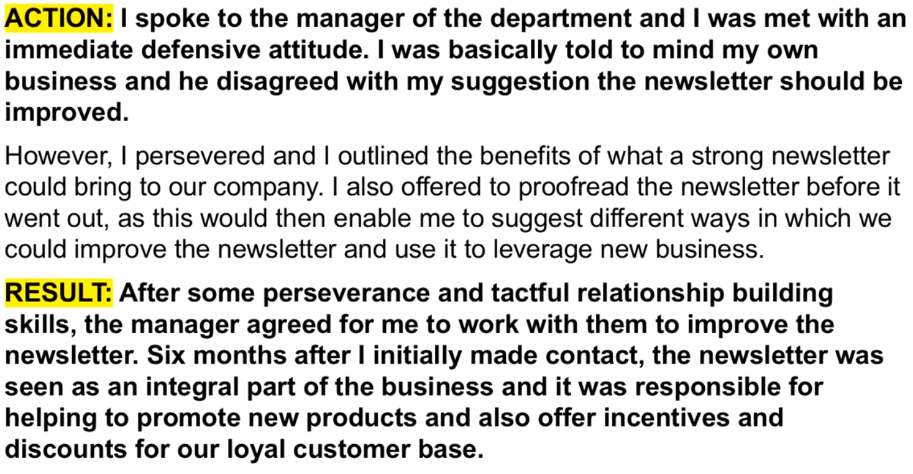

# **Q36.** [**Why do you want to be a Manager**](https://youtu.be/x7OWS6Wh0FE?t=204)**?**

## [**Option 1**](https://youtu.be/x7OWS6Wh0FE?t=207)

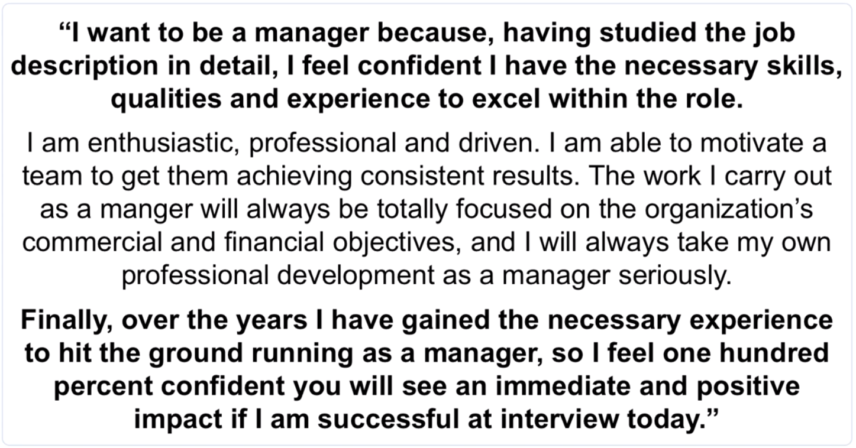

## [**Option 2**](https://youtu.be/x7OWS6Wh0FE?t=276)

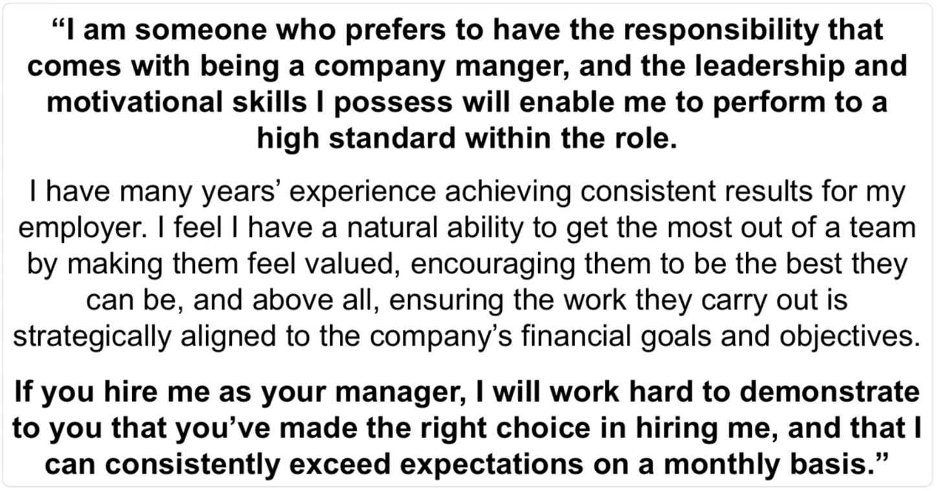

## [**Option 3**](https://youtu.be/x7OWS6Wh0FE?t=338)

